**Title: "Analyzing Climate Change Indicators: Unveiling Insights through Statistical Examination"**

**Name:**

**Abstract:**

This paper delves into the climate change indicator dataset curated by the World Bank, aiming to gain a comprehensive understanding of key variables such as urban population, agricultural activity, and electricity accessibility. Employing statistical analysis, we explore trends, correlations, and patterns, shedding light on the intricate relationships between diverse variables over time and across national borders.

**Introduction:**

Examining CO2 levels, urban population dynamics, electricity accessibility, and various other indicators, this comprehensive data visualization and analysis offer a nuanced understanding of their interplay and impact on climate changes in different regions. Drawing on reliable sources such as the World Bank, the study endeavors to unveil patterns, disparities, and potential associations among these pivotal parameters.

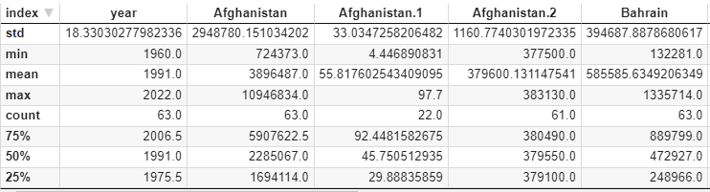

This is the summary of some countries by indicator first urban population, electricity access and agriculture land sq-km.

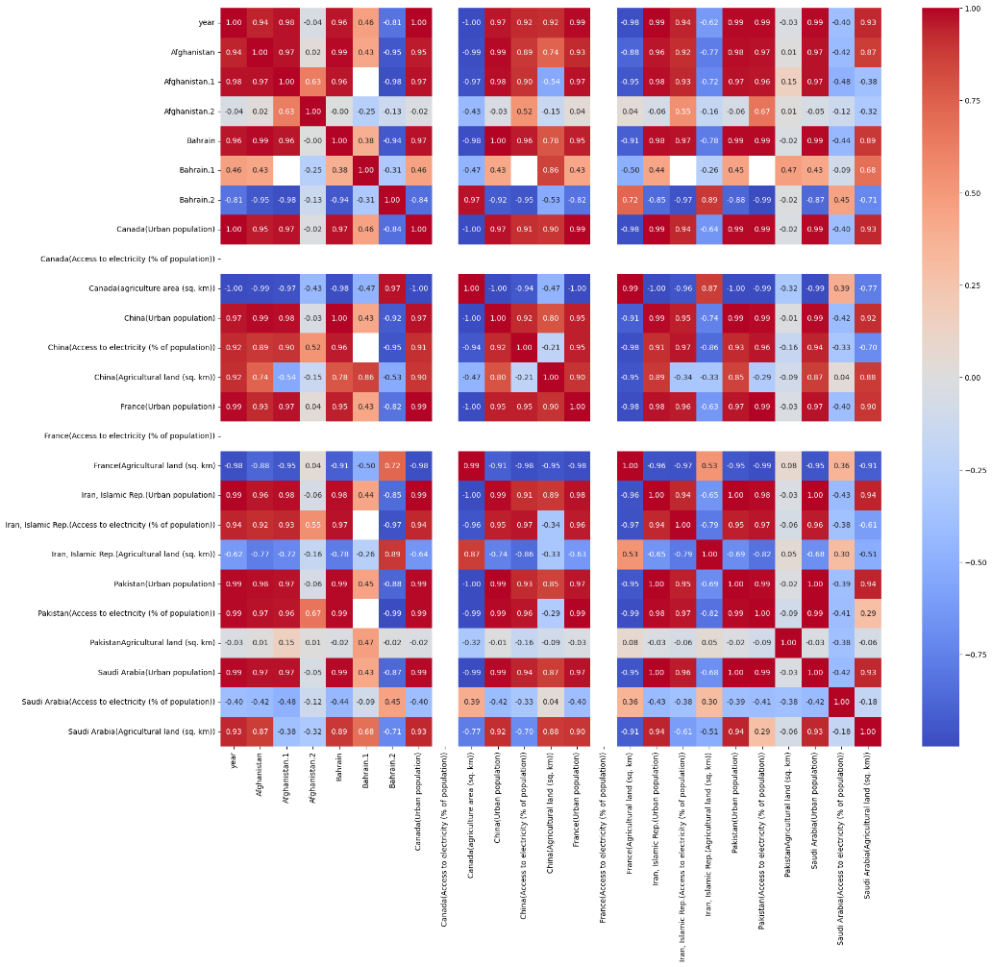

This is the correlation graph of different variables.

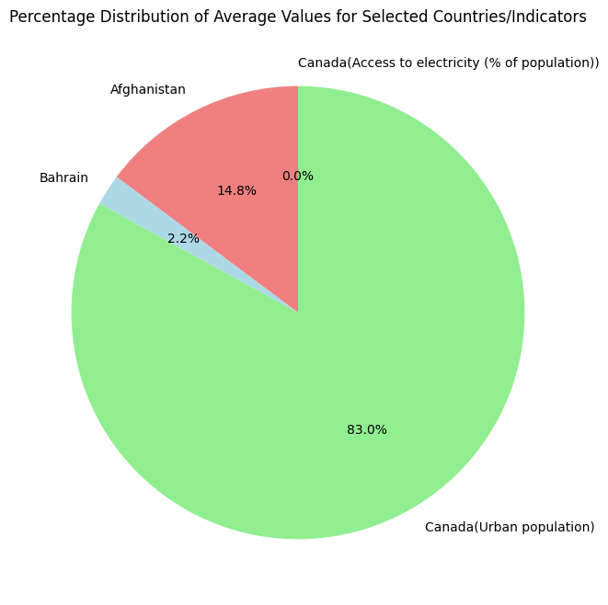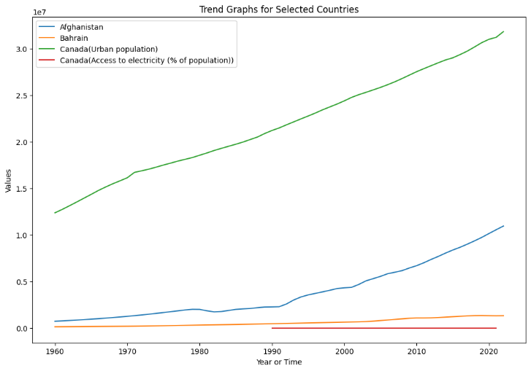

these are the bar graphs and the trend graph shows how the indicators change by time for different countries and tell the story of climate change the climate is rapidly change day by day.